**ALVA’S PRE – UNIVERSITY COLLEGE, MOODBIDRI.**

**NEET / JEE CRASH COURSE – 2020**

**DEPARTMENT OF CHEMISTRY**

**TOPIC – HYDROCARBONS (ALIPHATIC & AROMATIC)-C11**

**By – SD**



This reaction is known as :

1) Kolbe’s reaction. 2) Sand mayer’s reaction.

3) Diels – Alder reaction. 4) Fridel – Craft’s acylation reaction.

**Ans : 4 Fridel – Craft’s acylation reaction.**

1. Which is m – directing group ?

1) – C2H5 2) – OH 3) – CHO 4) – OCH3

**Ans : 3 – CHO**

1. Which is o - / p - directing group ?

1) – COOH 2) – NO2 3) – COCH3 4) – OCH3

**Ans : 4 – OCH3**

1. The reaction of toluene with chlorine in presence of ferric chloride gives predominantly :

1) Benzoyl chloride. 2) m – Chlorotoluene.

3) Benzyl chloride. 4) o – & p – Chlorotoluene.

**Ans : 4**

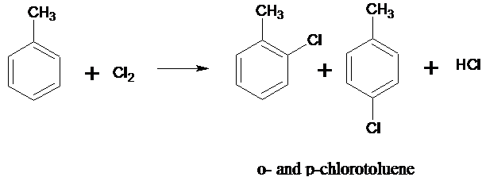

1. Which one of the following is most reactive towards electrophilic attack ?

1)  2)  3)  4) 

**Ans : 2 - OH is a powerful electron – donating group and hence phenol is most reactive towards electrophilic attack.**

1. On heating a mixture of sodium benzoate and sodalime, the following is obtained :

1) Toluene. 2) Phenol. 3) Benzene. 4) Benzoic acid.

**Ans : 3**

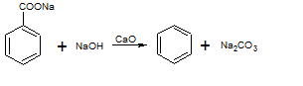

1. The non – aromatic compound among the following is :

1)  2)  3)  4) None of theses.

**Ans : 1 Cyclopentadiene, contains only 4n electrons and is also non – planar, therefore, it is non-aromatic.**

1. The species is :



1) Aromatic. 2) Non – aromatic. 3) Anti – aromatic. 4) Heterocyclic.

**Ans : 2 System is not conjugated. So, it is non – aromatic.**

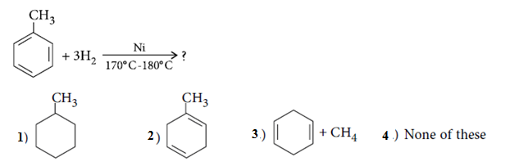

**Ans : 1 Under vigorous conditions, Ni / H2 will destroy the double bonds of benzene.**

Identify the product B ?

1)  2)  3)  4) 

**Ans : 1** - **NO2 group is m – directing.**



1. The major product Y is :

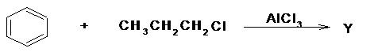

1)Cumene**.** 2) n – Propyl benzene. 3) Ethyl benzene. 4) Toluene & C2H5Cl.

**Ans : 1 Cumene.**

1. Identify ‘A’ in the following reaction :

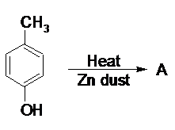

1) Toluene.2) Benzene. 3) Phenol. 4) Xylene.

**Ans : 1 Toluene.**

1. Which of the following species would be expected to exhibit aromatic character ?

I II III IV

1) I and IV. 2) II and IV. 3) I and III. 4) II and III.

**Ans : 4 II and III have delocalized 6n – electrons and hence are aromatic.**

1. The heat of hydrogenation of benzene is 51 kcal / mol. While its resonance energy is 36 kcal / mol. Then, the heat of hydrogenation of cyclohexene is :

1) 29 kcal / mol. 2) 14 kcal / mol. 3) 36 kcal / mol. 4) 22 kcal / mol.

**Ans : 1 Let x kcal mol-1 be the heat of hydrogenation of cyclohexene. Therefore, theoretical heat of hydrogenation of benzene which contains three double bonds should be = 3*x* kcal mol-1. But the actual heat of hydrogenation = 51 kcal mol-1. Difference of these two quantities must be equal to the resonance energy of benzene.**

**Therefore, 3*x* - 51 = 36**

**or 3*x* = 51 + 36 = 87 or x = 29.**

1. The reaction of toluene with Cl2 in presence of FeCl3 gives ‘X’ and reaction in presence of light gives ‘Y’. Thus, X and Y are :

1) X = benzyl chloride, Y = *m* – chlorotoluene.

2) X = benzal chloride, Y = *o* – chlorotoluene.

3) X = *m –* chlorotoluene, Y = *p* – chlorotoluene.

4) X = *o* - & *p* - chlorotoluene,Y = trichloromethylbenzene.

**Ans : 4**

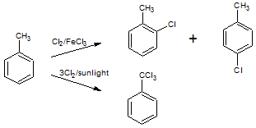

1. Which of the following participates in the sulphonation of benzene ?

1) SO2  2) SO3H+ 3) SO3  4) SO3H¯

**Ans : 3** **SO3 participates in the sulphonation of benzene.**

1. Decreasing order of rate of electrophilic substitution in the following arenes is :

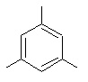 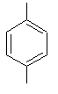 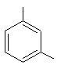 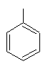

I II III IV

1) I > II > III > IV 2) II > III >IV > I 3) I >III > II > IV 4) II > I > III > IV

**Ans : 3** **In m - xylene, both the - CH3 group increase the electron density at each o - & p -position. While in p - xylene only one - CH3 group can increase the electron density at each o - position. Since p - position is blocked.**

1. In the following reaction, the product R is :



1) Benzene. 2) Toluene. 3) Chorobenzene. 4) Xylene.

**Ans : 2**

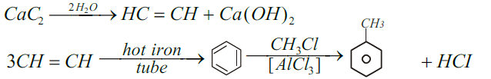

1. Which of the following will have fastest rate of reaction with Br2 / FeBr3.

1)  2)  3)  4) 

**Ans : 4**  - **OCH3 group is a stronger electron - donating group than - CH3 group, therefore, C6H5 – O – CH3 has the fastest rate of reaction with Br2 / FeBr3.**

1. Which of the following on oxidation with alkaline KMnO4 followed by acidification with dil. HCl does not give benzoic acid :

1) Toluene. 2) Ethylbenzene. 3) Isopropylbenzene.4) tert - Butylbenzene.

**Ans : 4** **Due to the absence of benzylic H - atom, tert – butyl - benzene does not undergo oxidation easily to give benzoic acid**.

1. An equimolar mixture of toluene and chlorobenzene is treated with a mixture of mixture of Conc. H2SO4 and Conc. HNO3. Indicate the correct statement from the following :

1) p - nitrotoluene is formed in excess.

2) Equimolar amounts of p - nitrotoluene and p - nitrochlorobenzene are formed.

3) p - nitrochlorobenzene is formed in excess.

4) m - nitrochlorobenzene is formed in excess.

**Ans : 1 - CH3 group is an activating group, while chloro group is a deactivating group towards electrophilic substitution reactions. Thus p - nitrotoluene is formed in excess.**

1. Which of the following will undergo meta substitation on mono chlorination :

1) Phenol. 2) Ethoxy Ethane. 3) Ethyl benzoate. 4) Chloro benzene.

**Ans : 3 - COOC2H5 is an meta directing group.**



What willbethe final product R ?

1) Benzene. 2) Nitrobenzene. 3) Tri nitrotoluene. 4) Tri nitrobenzene.

**Ans : 4**



1. Sulphonation of compound A followed by fusion with NaOH gives mixture of o - cresol & p - cresol. Compound A is :

1) Benzene. 2) Toluene. 3) Phenol. 4) Benzene sulphonic acid.

**Ans : 2**

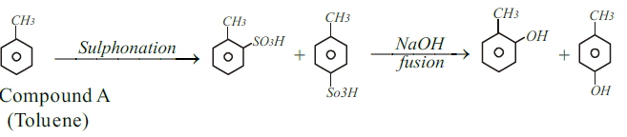

1. Identify *X* in the above reaction :

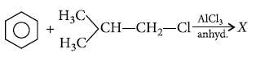

1)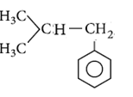 2)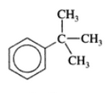 3)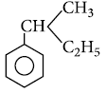 4)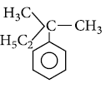

**Ans : 2 Tertiary carbocation more stable than primary carbocation.**

1. Which of the following is not an aromatic compound ?

1) 2) 3)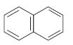 4)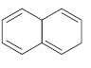

**Ans : 4 Molecule has 8Π - electrons, so does not follow Hückel’s rule. The orbitals of one double bond are not in conjugation so it is not an aromatic compound but all the other given compounds follow Hückel’s rule *i.e.*, (4*n* + 2)Π - electron rule.**

1. The correct order towards electrophilic substitution reaction is :



1) (iv) > (iii) > (ii) > (i) 2) (i) > (ii) > (iii) > (iv)

3) (iii) > (ii) > (i) > (iv) 4) (iii) > (iv) > (i) > (ii)

**Ans : 4 – NHCOCH3 group is more activating than isopropyl group.**

1. Which of the following has the least heat of hydrogenation ?

1) 1, 3 – Cyclohexadiene. 2) Benzene.

3) 1, 3, 5 - Cyclohexatriene (hypothetical) 4) 1, 3 – Butadiene.

**Ans : 2 More stable the compound, lower is the heat of hydrogenation. Thus, benzene has the lowest heat of hydrogenation ( - 208.36 kJ mol-1) as compared to**

**1, 3 - butadiene or 1, 3 - cyclohexadiene ( - 119.66 x 2 = - 239.32 kJ mol-1) and**

**1, 3, 5 - cyclohexatriene ( - 119.66 x 3 = - 358.98 kJ mol-1).**



1)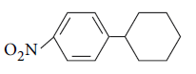2)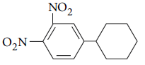3)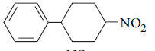4)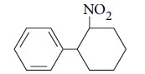

**Ans : 1 Nitration will take place at *o* - or *p* - positions of the aromatic ring if + *I* - effect group is attached to the benzene ring. Lower temperature prevents poly - nitration.**

1. Which among the following is aromatic ?

   

I II III IV

1) I 2) II 3) III 4) IV

**Ans : 1 I has 10 (pi) – electrons and hence is aromatic ; II has 4 (pi) - electrons and**

**hence is antiaromatic ; III is tub shaped and has 8 (pi) - electrons, therefore, it is non - aromatic ; IV has 9 (pi) - electrons, and hence is non - aromatic.**

1. Which of the following represents the given mode of hybridization; sp2 – sp2 – sp – sp from left to right ?

1) CH2 = CH – C ≡ N2) CH ≡ C – C ≡ CH

3) CH2 = C = C = CH2 4) CH2 = CH – CH = CH2

**Ans : 1 CH2 = CH – C ≡ N**

1. The number of and - bonds in cyclohexene :

1) 16 & 3 2) 13 & 2 3) 16 &1  4) 12 & 2



**Ans : 3**

1. The correct order regarding electronegativity of hybrid orbitals of carbon is :

1) sp < sp2 < sp3 2) sp < sp2 > sp3 3) sp > sp2 < sp3  4) sp > sp2 > sp3

**Ans : 4 sp > sp2 > sp3**

1. The hybridized state of carbon in H2C = O is :

1) sp 2) sp2 3) sp3 4) s2p

**Ans : 2** sp2

1. Ph – C ≡ C – CH3 A. Identify ‘A’.



**Ans : 2**



1. Which of the following correctly represents the + I effect of the substituents ?

1) O- > COO- > CR3 2) COO- > O- > CR3 3) O- < COO- < CR3 4) COO- < O- < CR3

**Ans : 1 O- > COO- > CR3**

1. The correct IUPAC name of the following compound is :



1) 4 – Ethyl – 5 – methylhexa – 1, 3 – diene. 2) 3 – Ethoxy – 4 – methylhexa – 1, 4 – diene.

3) 3 – Ethyl – 4 – methylhexa – 1, 4 – diene. 4) 3 – Ethoxy – 4 – methoxyhexa – 1, 4 – diene.

**Ans : 3**

** IUPAC name is ; 3 – Ethyl – 4 – methylhexa – 1, 4 – diene.**

1. Which of the following is incorrect for the incomplete statement, ‘The members of the homologous series of alkanes is / are………’

1) All straight chain compounds. 2) Have the general formula CnH2n+ 2

3) Have similar chemical properties. 4) Show a regular gradation of physical properties.

**Ans : 4 Show a regular gradation of physical properties.**

1. Which of the following statement is correct ?

1) Allyl carbocation is less stable than isopropyl carbocation.

2) An acidic reagent donate H+ ion to solution.

3) - I effect is exhibited by (R)2NH. 4) The formula CH2Cl2 is non – polar.

**Ans : 2 An acidic reagent donate H+ ion to solution.**

1. The central carbon atom of alkyl free radical possess :

1) 6 electrons. 2) 8 electrons. 3) 7 electrons. 4) 2 electrons.

**Ans : 3 7 electrons.**

1. Which of the following acts as both electrophile and nucleophile ?

1) CH3 – N+ ≡ C– 2) :NH3 3) H2C = 4) BeCl2

**Ans : 3**



1. Which of the following organic compound contains about 52% carbon ?

1) Ethanal. 2) Dimethyl ether. 3) Acetic acid. 4) Phenol.

**Ans : 2 CH3 – O – CH3 or 46g of C2H6O contains 2 x12 = 44g of C , hence, %C = $\frac{24 X 100}{44}$**

**= 52.3 ~ 52%.**

1. A compound A with molecular formulaC6H10 on oxidation with hot alkaline KMnO4 gives hexandioic acid. Then A is :

1) 2 – Hexyne. 2) 1,5 – Hexadiene. 3) 1, 3 – Hexadiene. 4) Cyclohexene.

**Ans : 4**



1. In hyperconjugation of an alkene there is overlap between :

1) p - and Π orbitals. 2) Two Π orbitals. 3) d - and Π orbitals. 4) σ - and Π – orbitals.

**Ans : 4 σ - and Π – orbitals.**

1. Ozonolysis of hydrocarbon gives one mole of acetone and one mole of formaldehyde. The hydrocarbon is :

1) Propene. 2) 2 – Methylpropene .

3) 2 – Methyl – 2 – butane. 4) 2 – Methyl – 1 – butane.

**Ans : 2**

